 | DONATION FORM  Lights for Auntie Lee

DONOR INFORMATION
[ ] Corporate Donor [ ] Individual Donor
Full Name (Dr/Mr/Mrs/Ms): _____________________________________________________________________
Organisation: ______________________________________ Contact Person: _____________________________
Mailing Address: ______________________________________________________________________________
Postal Code: ________________E-mail: _________________________Tel / Mobile No.: ____________________
FOR TAX DEDUCTION, MUST PROVIDE:
NRIC/FIN (Individual): _______________________________ UEN (Corporate): ____________________________
DONATION
I would like to donate $___________________________*monthly / one-time to support the Home’s utility bills.
(*delete as necessary)
PAYMENT OPTIONS

[ ] Cheque (enclosed), Bank: ___________________ Cheque No.: _________________________________
Please make cheque payable to St. John’s Home for Elderly Persons

[ ] Visa / Mastercard Credit No.: __ __ __ __ -- __ __ __ __ -- __ __ __ __ -- __ __ __ __
Name on Card: _________________________________________ Expiry Date (mm/yyyy): __ __ / __ __
[ ] Internet Banking
Bank: UOB Bank Account No.: 956-342-326-5 Bank Code: 7375 Branch Code: 004
[ ] PayNow
UEN: S61SS0176G1GF 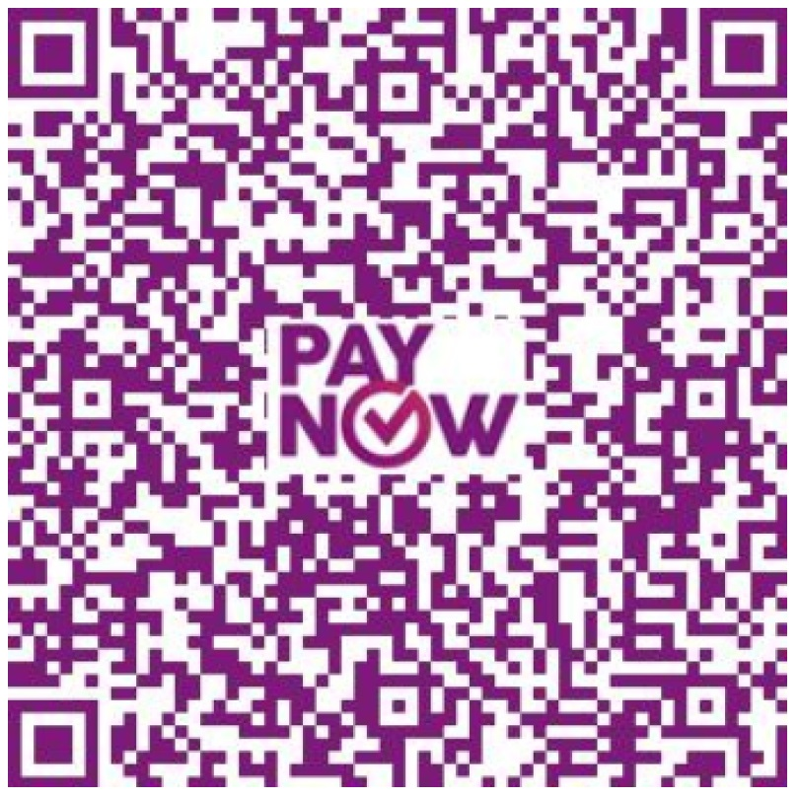

ACKNOWLEDGEMENT
I agree to let St. John’s Home for Elderly Persons use my personal information for the following purposes related to:
1) Issuing of tax-deduction receipt and submission of the receipt to IRAS; 2) Fundraising; 3) Marketing and Communications

______________________________________ ___________________________
Donor’s Name / Signature Date

