 | DONATION FORM  Pau for PA

DONOR INFORMATION
(Dr/Mr/Mrs/Ms) Surname or Family name: _______________________ Name: ________________________________
Organisation Name: ___________________________________________ Contact Person: ________________________
E-mail: ________________________________________________________Tel No.: _______________________________
Mailing Address: _______________________________________________Postal Code: __________________________
FOR TAX DEDUCTION, MUST PROVIDE:
NRIC/FIN (Individual): _______________________________ UEN (Corporate): _________________________________
OTHER INFORMATION:
Age: [ ] above 65 [ ] 55 to 64 [ ] 45 to 54 [ ] 35 to 44 [ ] below 35 Occupation: _________________________
DONATION
I would like to donate $________________ to support the Home’s residents under the Public Assistance Scheme.
[ ] $900 to pay for one month of care to one PA resident.
[ ] $5,400 to pay for six months of care to one PA resident.
PAYMENT OPTIONS

[ ] Cheque (enclosed), Bank: ___________________ Cheque No.: _________________________________
Please make cheque payable to St. John’s Home for Elderly Persons

[ ] Visa / Mastercard Credit No.: __ __ __ __ -- __ __ __ __ -- __ __ __ __ -- __ __ __ __
Name on Card: _________________________________________ Expiry Date (mm/yyyy): __ __ / __ __
[ ] Internet Banking
Bank: UOB Bank Account No.: 956-342-326-5 Bank Code: 7375 Branch Code: 004
[ ] PayNow (UEN: S61SS0176G1GF)
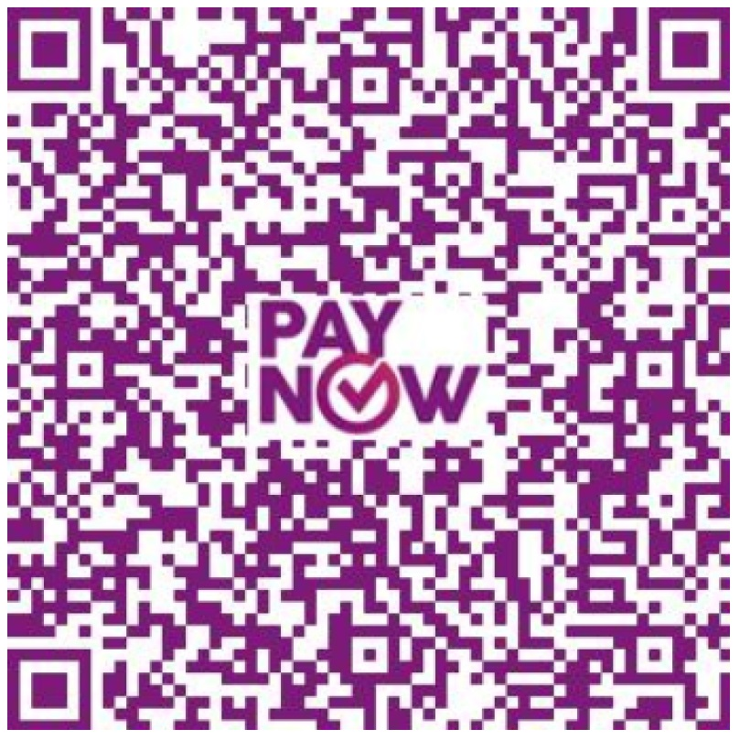
[ ] https://www.giving.sg/StJohnsHomeSG/pa
ACKNOWLEDGEMENT
I agree to let St. John’s Home for Elderly Persons use my personal information for the following purposes related to:
1) Issuing of tax-deduction receipt and submissions to IRAS; 2) Fundraising; 3) Marketing and Communications

______________________________________ ___________________________
Donor’s Name / Signature Date

